02.02 The IDLE and Arithmetic Expressions

Integrated Development and Language Environment

Software development tools can be combined into one bigger software package, called an Integrated Development Environment. Visual Basic’s is called Visual Studio. Python has several – we will use the IDLE or Integrated Development and Language Environment.

The IDLE contains a native text editor, the Python interpreter, and tools to help run and debug programs. It can be accessed in the Python 3.x entry in the Windows program list. Select IDLE Python (64-bit).

Initially, the IDLE will look and act like the Python Shell:

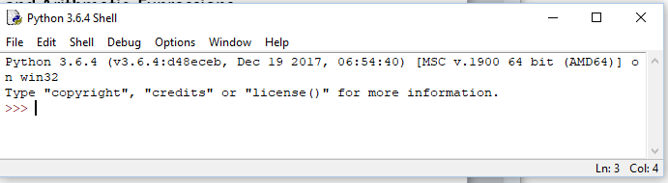

However, it can be switched to an editor mode with the following set up steps.

- Choose Options | Configure IDLE
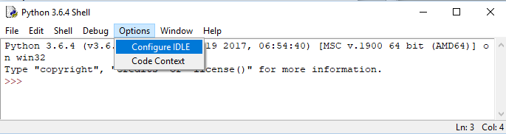

- Then General | Open Edit Window.
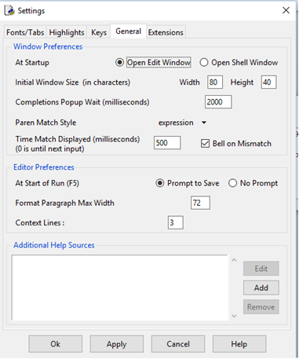

- Click on Ok.

- Close the IDLE, then re-open. It will now start in the Edit Window mode.
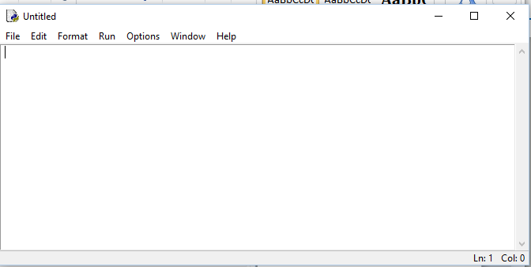

Unlike Python shell, pressing Enter will now not activate the interpreter right away. Multiple lines can be written first, without the interpreter trying to run the program, then run together at one time.

However, before running any changes, the program must be saved first:
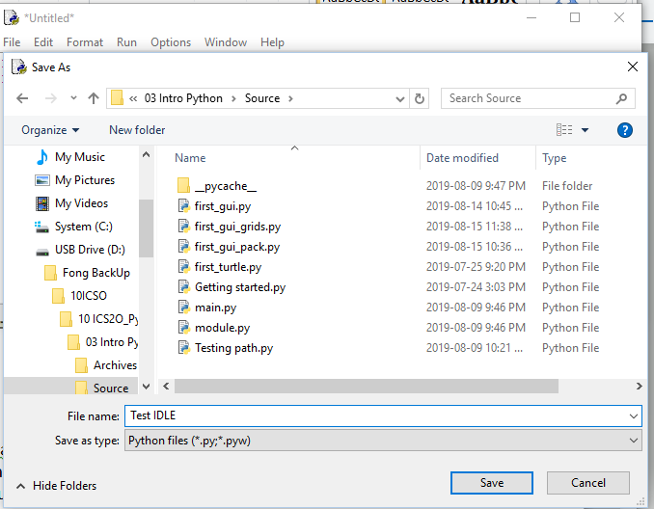

Notice the file extension. *.py indicates a Python program, written with a text editor.

After saving, the IDLE will allow you to run your program.

While typing, the IDLE will also give hints:
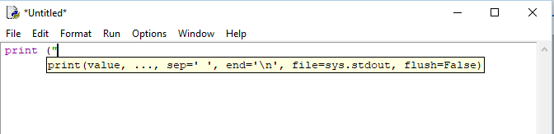

To run the program, select Run | Run Module

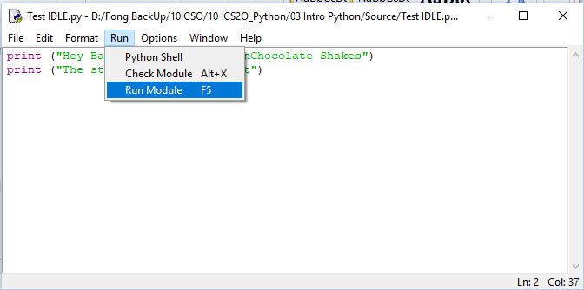

A Python shell will appear, displaying the results of your program.
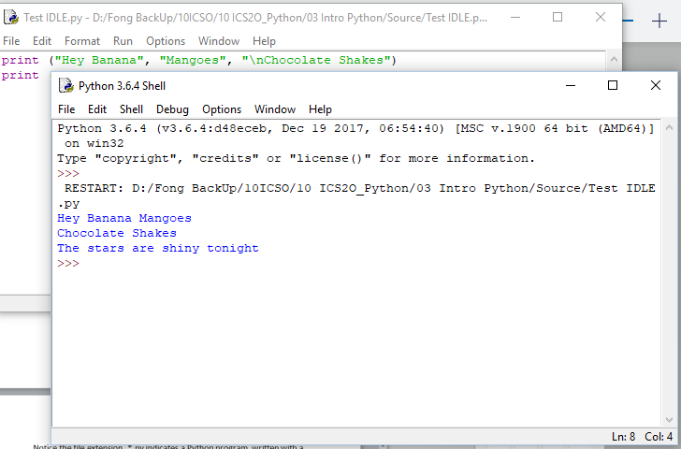

Select File | Close to close the shell, and return to the Edit Window.

Arithmetic Expressions

The arithmetic operations +, -, *, / work just like in mathematics, with one thing to watch out for.

Try:
i) 1 + 1
ii) 6 * 3
iii) 4.5 + 3
iv) 5.05 – 10.3 What seems unusual about this result?

Example iv) may look wrong but it is not, from a programming sense (it’s wrong in a pure math sense though). The issue is a technical issue that experienced programmers learn how to handle. It is a fact that numbers some real numbers with non-zero decimal digits cannot be exactly represented in binary. The pure math answer to iv) is -5.25, but we get extra digits to the right of the decimal point due to how that number is stored. Non-integer numbers in computer science are called floating point numbers.

One straightforward way to address this is to use the round() command or function to remove the extra digits.
The general form of the function is round (number, digits) where digits is the number of digits to round to after the decimal.
Languages make use of commands or functions to perform many duties – print() is another command.

When writing code that uses floating point numbers, the programmer must anticipate how many decimal digits they want.
Example iv) could be written as

round (5.05 – 10.3, 2)

to get -5.25.

What are the data types for the operands and the results? (Operands are the numbers or input used in an expression)
v) 10 / 2
vi) 12.0 / 6.0

Adding, subtracting and multiplying results will be integer if both operands are integer, and floating point if either is floating point.
Division will result in a floating point answer regardless of operand data type.

Exponents are written as 2 ** 3 (two asterisks side-by-side).
Did you know that a square root can be written as an exponent? The power of ½ or 0.5 means square root. So 25 ** 1/2 or 25 ** 0.5 equals 5.

Try (carefully note where there are blank spaces)

- 2 ** 3
- 3**2
- 5 * * 2
- 100 ** 0.5

Conventions are rules that will not affect how the program runs, but have been adopted by programmers over the years as they have proven to be useful for maintaining/updating the programs.
By convention, there should be spaces before and after the arithmetic operators.
Eg 3 + 5 Follows convention
3+5 Does not follow convention

Some differences:

What happens with 1 \ 3? (Notice the slashes are different)

What about 3(4)? Try this.

The BEDMAS rules still hold:

Try:
- (2 + 3) * 5
- 2 + 3 * 5

Try:
print (2 + 3 * 5)
The print() function can work with more than strings in its parameters.
Strictly speaking, the results are converted to string data type.

We have seen that Python can work with numbers.

Try:
- 5 + 5
- “5 + 5”
- “5“ + “5”
- 5 + “5”

For i), Python sees two number fives, and interprets “+” to mean addition.

For ii), Python just sees 1 string without any explicit command to indicate what to do with the string, so it just echoes the string. The single apostrophe ‘, is equivalent to double apostrophe “.

For iii), Python sees two strings. Strings cannot be (numerically) added – so the “+” operator does perform addition. However, Python will combine the two strings into one string, called concatenation.

For iv), Python detects two operands of different data types, so does not know to add or concatenate. A syntax error results.

Exercises 02.02 Arithmetic Expressions and the IDLE

02.02.01
Make sure your IDLE opens up in Edit Window mode.

The remainder of the course’s exercises are to be done using the IDLE (unless specified otherwise).

02.02.02
Convert the following mathematical expressions into Python code, and print the answers, printing one answer per line. Remember to write using the print() command. For example, print ( 1+1). Save this 6 line program in a file, and name it 02.02.02 Arithmetic.py and save it in your save folder on your USB drive.

- 2 multiplied by 3
- 2 + 3 x 5
- (2 + 13) / 5
- 2⁵
- 7/3 – 1
- (7 – 12) / (6 – 1)

02.02.03
Create a geometry program circumference.py that prints the circumference (2(pi)r) of a circle with radius 15 cm. Use the value 3.14 for pi. Verify your program’s calculation manually.
- Write a program that just displays the calculated answer.
- Modify the program so that the answer is printed as:
“The circumference is XX cm”, where XX is the calculated answer.

02.02.04:
Create a LongJumpAverage.py application that calculates and displays the average jump length of an athlete whose jumps were 3.3 m. 4.0 m and 3.0 m.
- Write the entire calculation in one print statement
- Apply the round () command to round the answer to 2 decimal places by nesting the commands like this
print (round ((1 / 3), 2))

Advanced: Number validation

Write this program without using conditional statements (IF’s) nor loops (WHILE, FOR).

An important activity in the digital world is validating identification numbers. Numbers (eg credit card numbers) can be erroneously entered, or be transmitted with an error. The idea of a checksum is so that a number can be self-validated.
- Write a program to calculate the checksum for a six-digit identification number that the user inputs. The algorithm is as follows:
- sum up the 1st, 3rd and 5th digits.
- double the 2nd digit and, if it is a single single digit product, add that digit
- if the doubled number is 2 digits, then add the two digits as separate numbers
- repeat ii, ii with the 4th and 6th digits
- find the single digit number that, when added to the sum, creates a two digit number that ends in zero
- this single digit number is the checksum

For example:
176248
1 7 6 2 4 8
1 14 6 4 4 16 double the even numbered
digits
1+ 1 + 4 + 6 + 4 + 4 + 1 + 6 = 27

Since 27 + 3 = 30, 3 is the check sum.

- Using your knowledge from a), write a program that takes a 7 digit number comprised of : i) a six digit identification number, and ii) a check sum, and determine if the identification number is valid.
The identification number is valid if the 7th digit is the correct checksum for the 6-digit identification number.

Using the example from a) the number 1762483 is the number transmitted.

